HIGHLIGHTS OF SPE ACTIVITIES IN KNUST STUDENT CHAPTER 2024
SPE is a very educative society to be a member of, therefore, it is very necessary to participate fully in its activities where knowledge is exchanged, being innovative is crucial and more importantly gaining professional competence in the exploration and production of oil and gas in a safe manner.
- SPE STUDENTS’ ORIENTATION FOR FRESHMEN
To help foster undiluted participation in SPE activities in the chapter, an orientation section was organized in collaboration with the college executives to create the awareness of SPE and increase our membership by recruiting interested students.
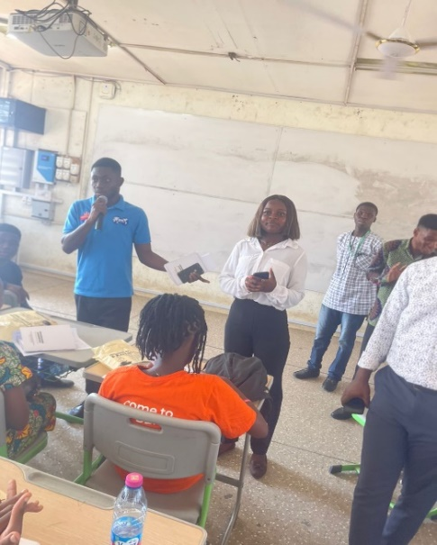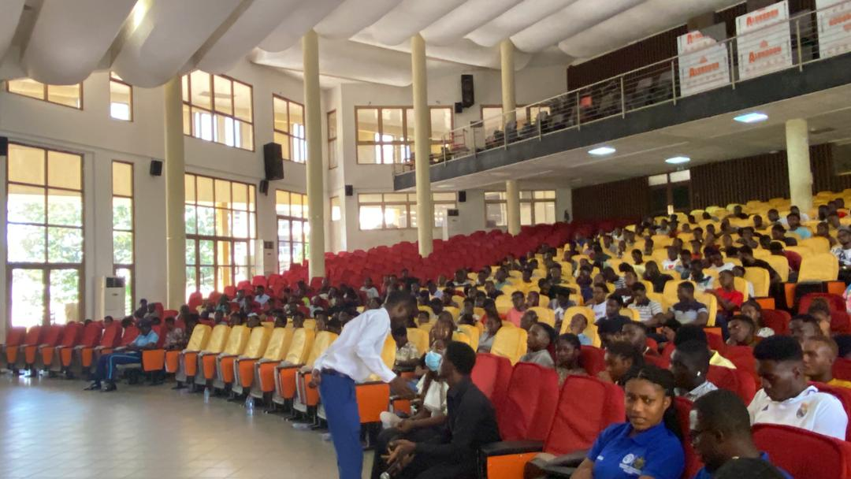
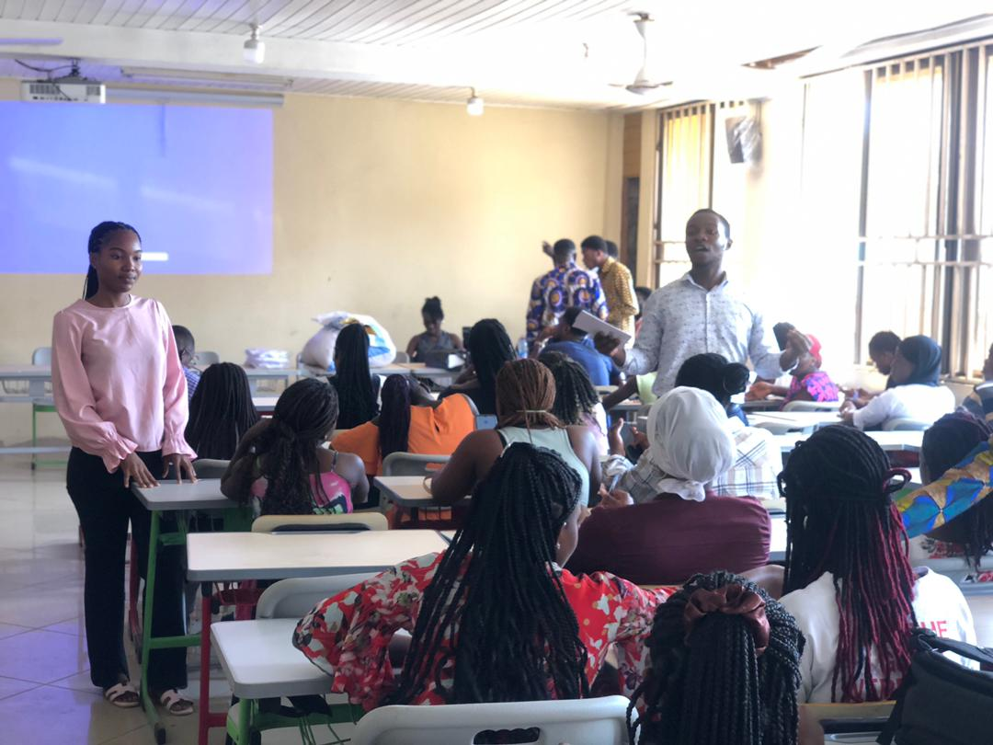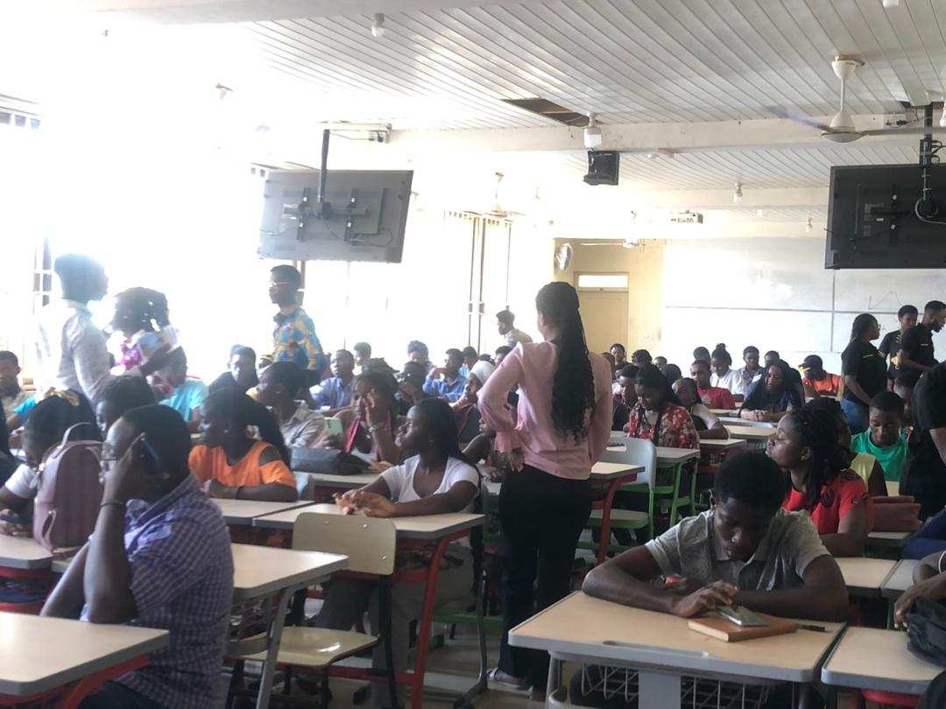
- SEMINAR FOR STUDENTS ON PERSONAL BRANDING AS ENGINEERS.
Personal branding is a powerful tool for student engineers to differentiate themselves, attract opportunities, and advance their careers. By defining their unique value proposition, building a professional online presence, showcasing their projects and achievements, actively networking, demonstrating thought leadership, and seeking feedback, student engineers can establish a strong personal brand that resonates with employers and industry professionals. Due to this, the chapter took upon itself to organize a webinar for student members to enhance their persona.
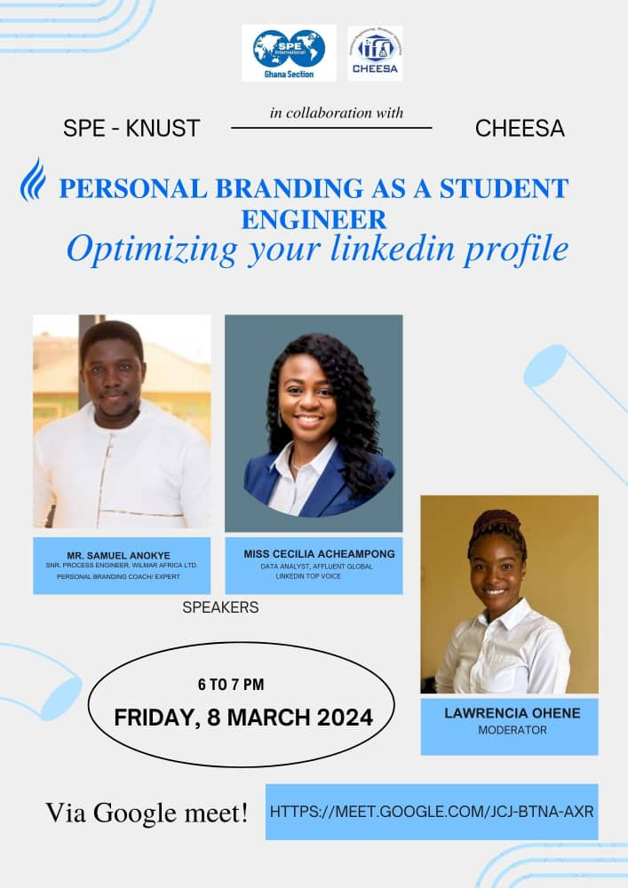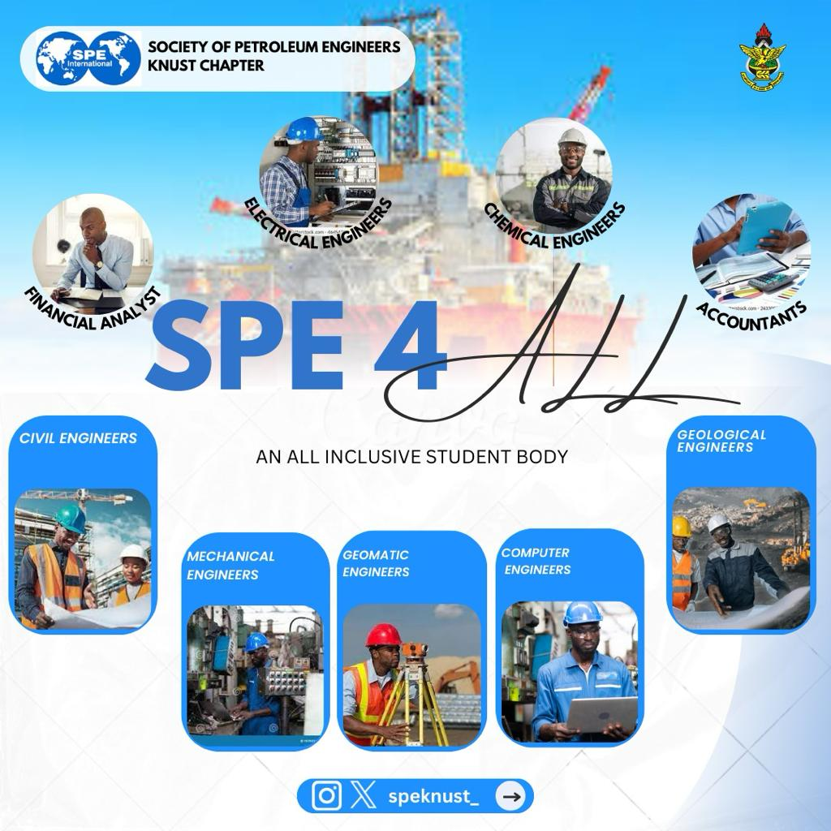
In conclusion, Seminars are extremely significant in the lives of students. They are extremely beneficial to students since they enable them to evaluate, stay up to date on current events, comprehend concepts, and build their network. The seminars we have had so far has helped students gain more knowledge about SPE and its role it plays in contributing to the oil and gas industry.
- INAUGURATION OF THE KUMASI TECHNICAL UNIVERSITY SPE CHAPTER.
The inauguration of a new student chapter is a significant milestone for any educational institution. It marks the beginning of a platform where students can engage, learn, and collaborate in their chosen field of interest. As an already established chapter, we had the privilege and outmost honor to join the leadership of SPE Ghana to inaugurate the KsTU chapter.
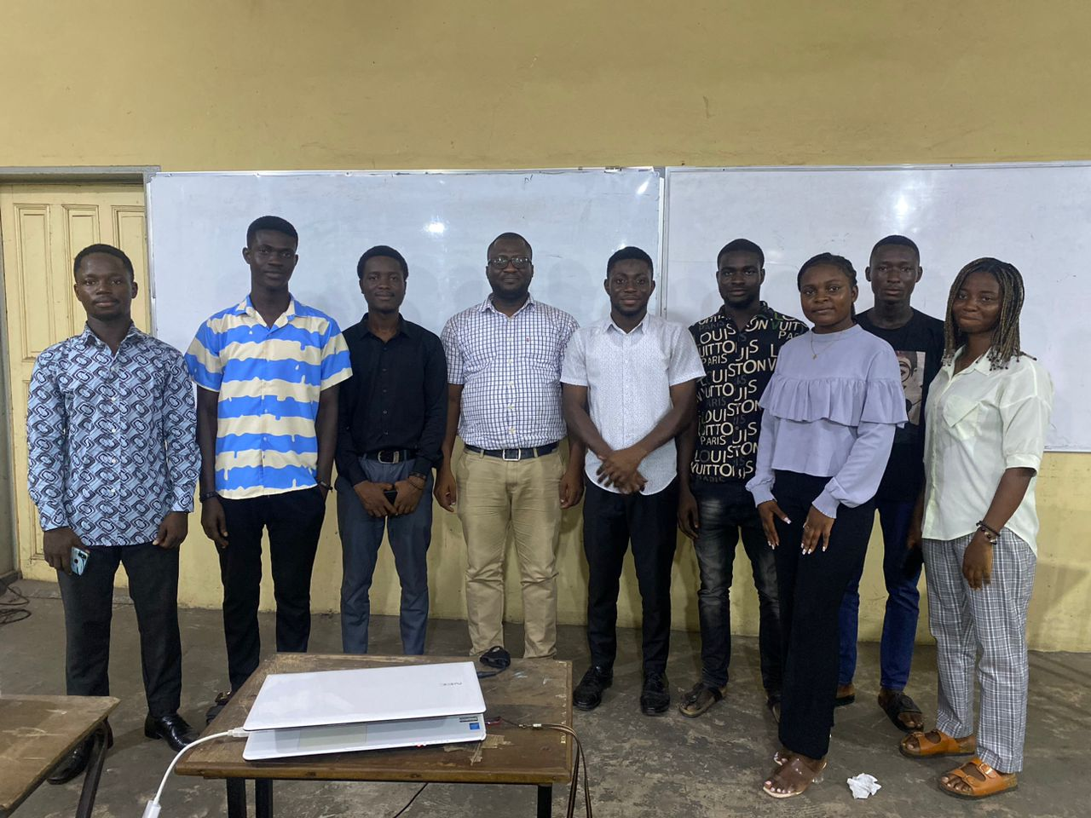
The inauguration of the KsTU chapter marks the beginning of an exciting journey towards academic and professional excellence. By providing a platform for collaboration, learning, and networking, the chapter aims to empower students and contribute to their holistic development.

- COLLABORATIVE MEETING WITH SPE KSTU
Collaborative meetings play a crucial role in fostering teamwork, sharing ideas, and making collective decisions within organizations. As neighboring student chapters, we organized a meet up section where we shared ideas and plans for the future for the betterment of the section and students at large.
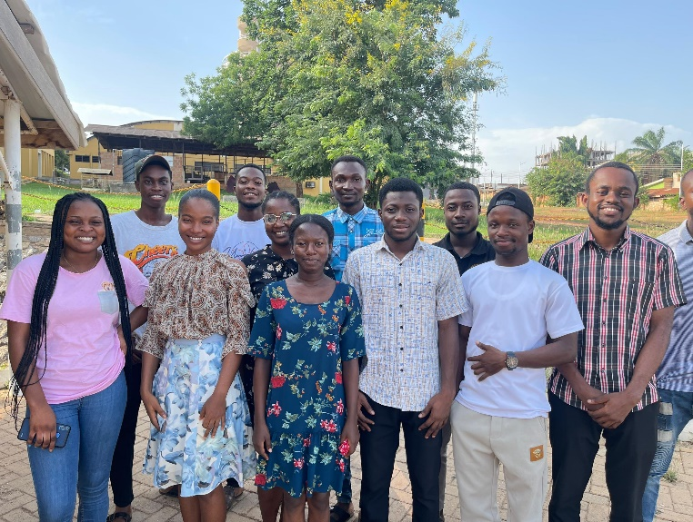

- MEET AND GREET SEMINAR WITH NATIONAL EXECUTIVES
Embarking on a professional journey can be both exciting and daunting. It requires a blend of skills, perseverance, and adaptability to navigate through the challenges and opportunities that arise. This report outlines key strategies to help individuals navigate their professional journey effectively. Due to this, we had the privilege to meet our national executives in the person of Mrs. Sheena Owusu-Ansah (Section Chairperson) and Mr. Derick Klutse (Head of the career guidance and outreach committee). It was a moment worth having and time worth dedicating.
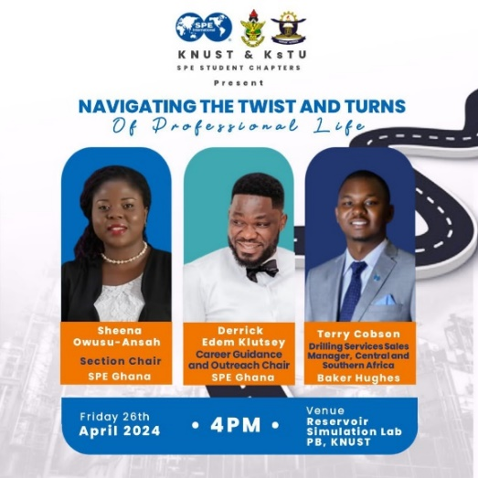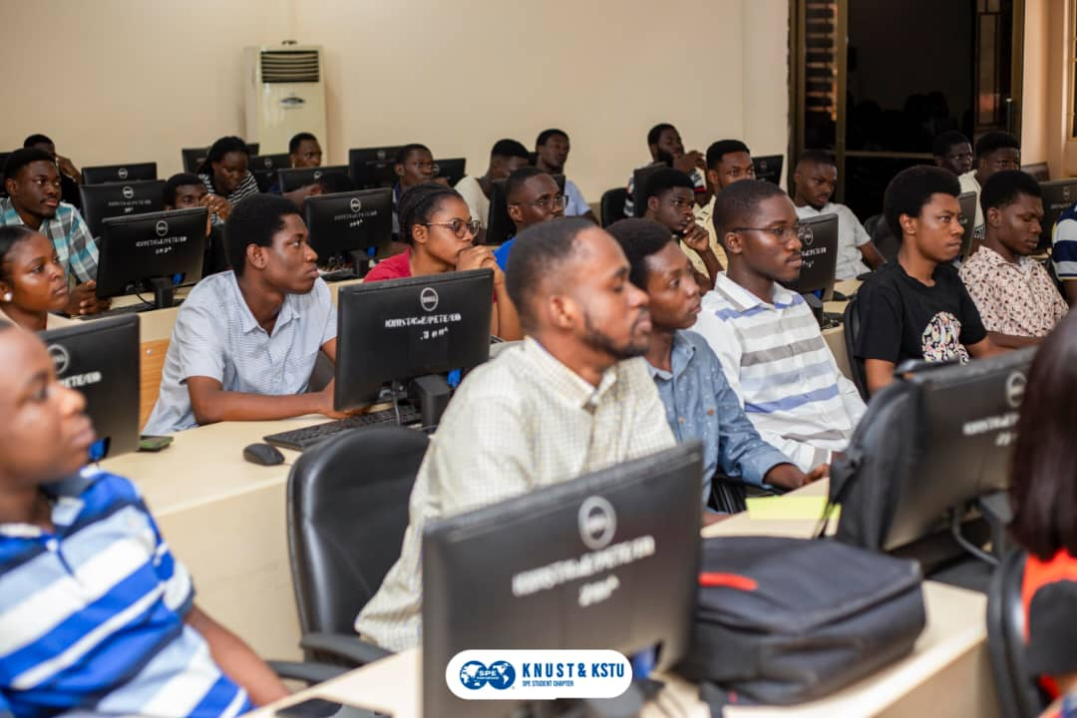
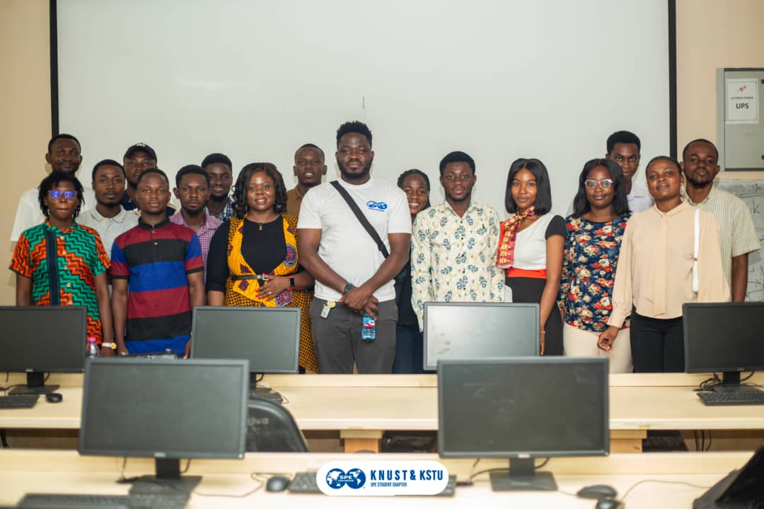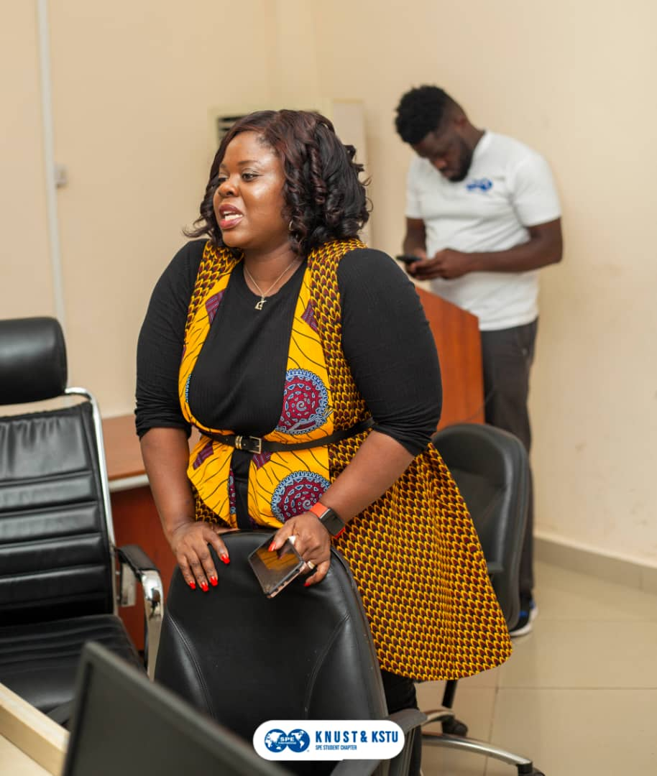
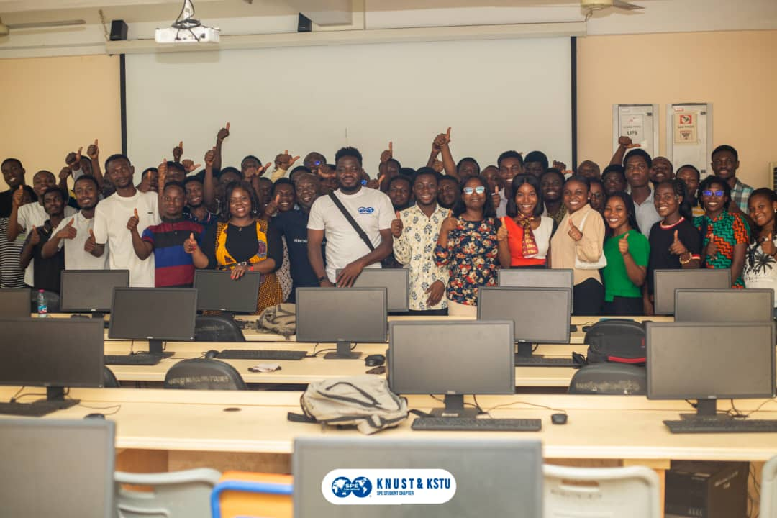

- STUDENT PAPER CONTEST QUALIFICATION
We were excited to have three of our members qualify for the African student paper contest which was to take place in Uganda early this year.
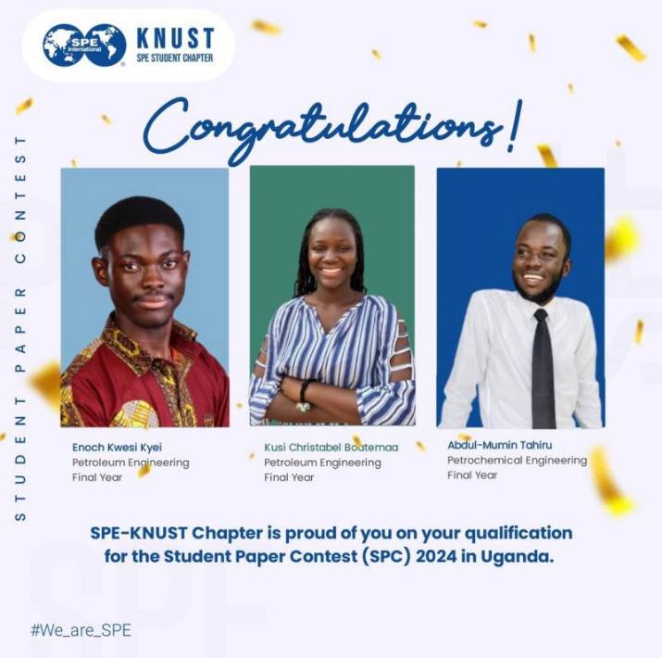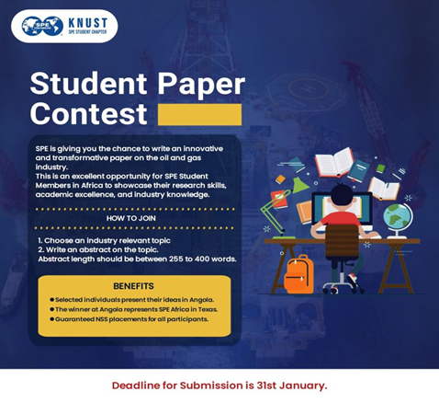
- PETROBOWL QUALIFICATION
KNUST emerged victorious as the champions of the SPE Ghana petrobowl competition.. The chapter will proudly represent Ghana and Africa at the SPE ATCE in New Orleans, USA at the International PetroBowl competition.
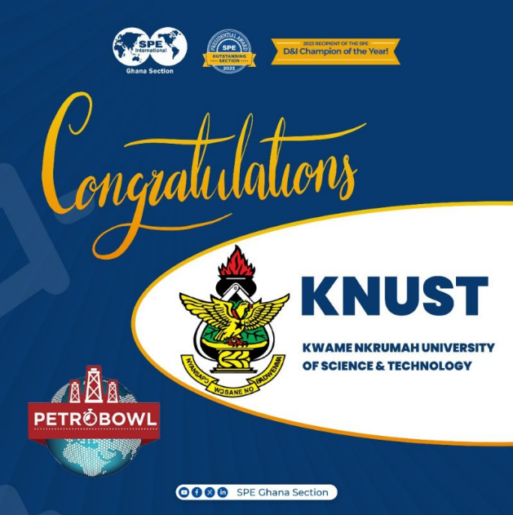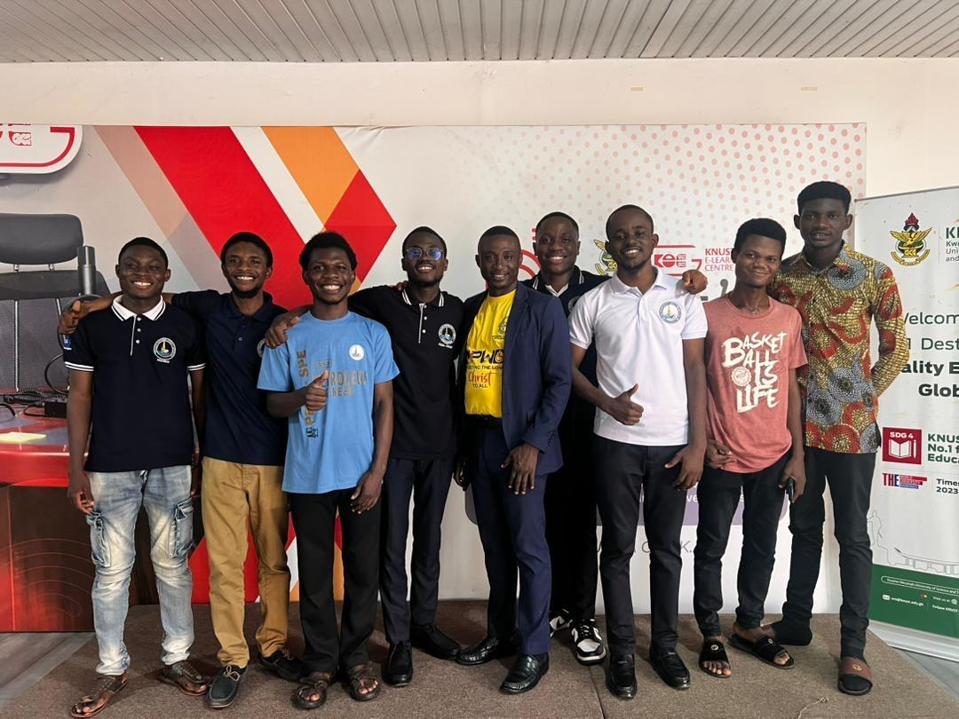

- SpeKNUST-TEDx Colaboration Event
SPE KNUST in collaboration with TEDxKNUST organised the second edition of TEDx conference which brought on board several talented individuals to share their thoughts and inspire young generations. This was an event that was sponsored majorly by SPE Ghana section with Dr. Riverson Oppong representing the section at large.
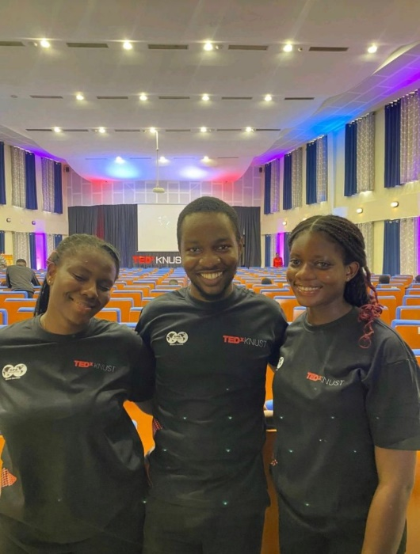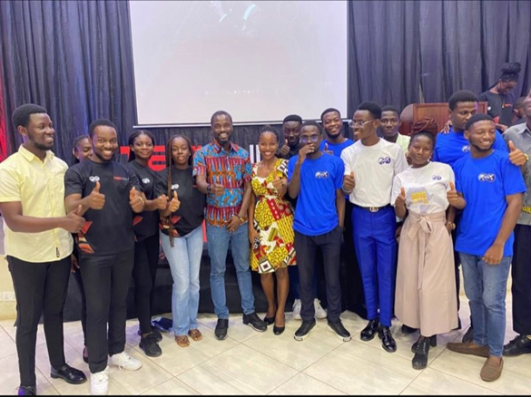
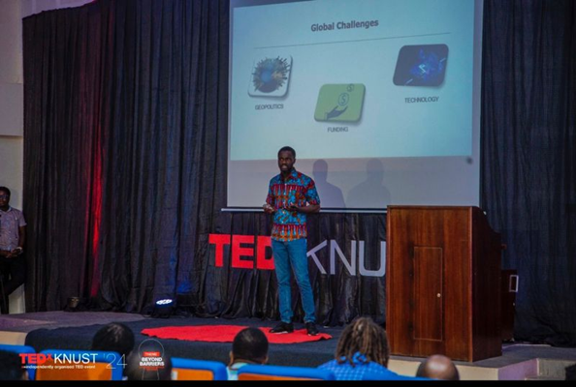

- OUTSTANDING STUDENT RECOGNITION
We were excited to have two of our students being recognized at the just ended GH-BISE event for their outstanding contribution towards the section. In recognition was Mr. Abdul Razak Suleman and Miss. Lawrencia Ohene
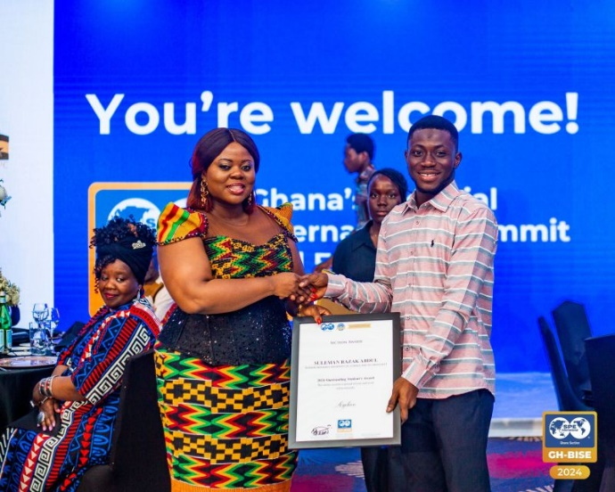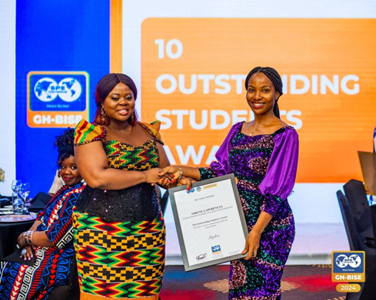

- TREE PLANTING EXERCISE
We embarked on our highly anticipated tree planting exercise which took place at the college of Engineering (KNUST) as part of our contribution towards the world environmental awareness month. The enthusiasm and excitement our members brought on board was so warming and assured as the need for conserving our environment. We would also want to express our outmost gratitude to the Department of Petroleum Engineering, KNUST for sponsoring this initiative, the department of Agriculture,KNUST, and our faculty advisor Stephen Adjei, Ph.D.
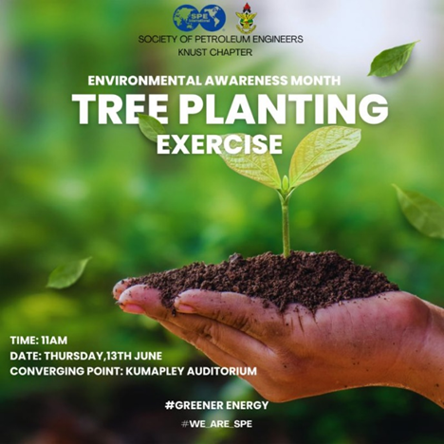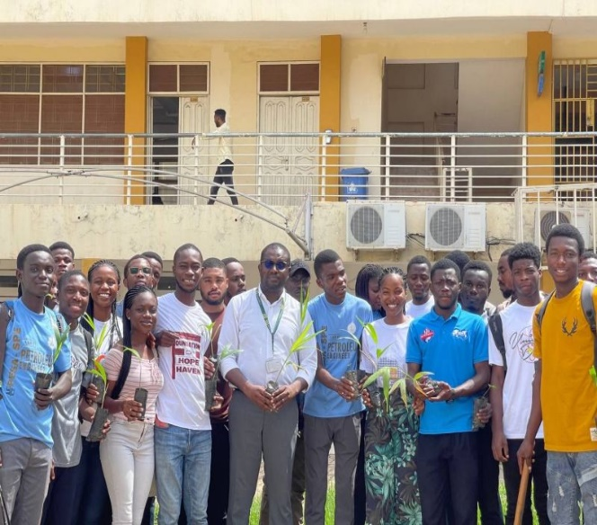
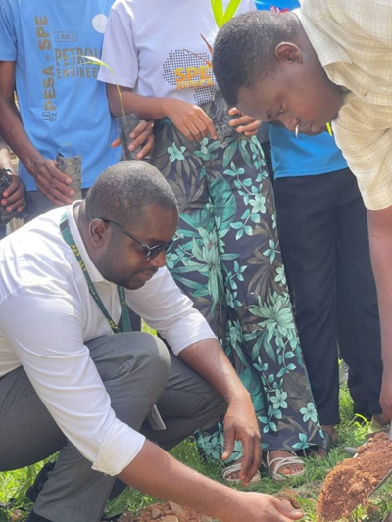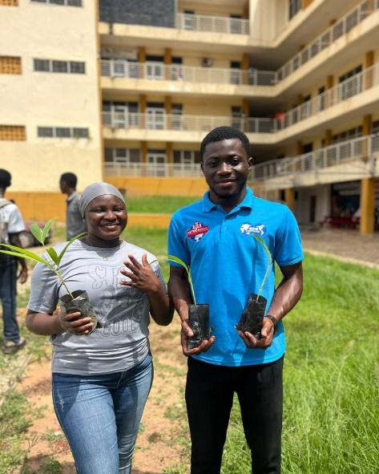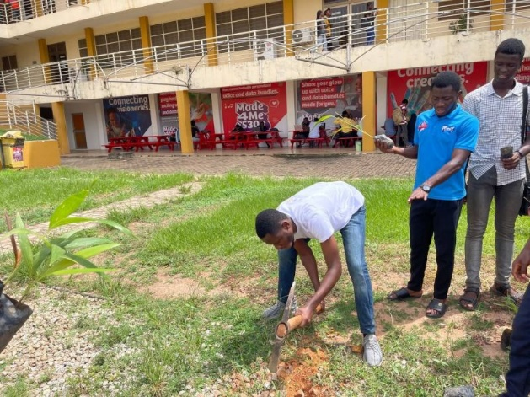

- ATTENDANCE ON NATIONAL EVENTS
Our executives were in attendance at the recent GH-BISE event held at Alisa Hotel, Accra by the Society of Petroleum Engineers - SPE Ghana Section. As a student body, we were delighted to partake in this event throughout. It was an honor to represent KNUST together our very own Yen Adams Sokama-Neuyam, Ph.D, the head of department for the Department of Petroleum Engineering, KNUST gracing the occasion as well.
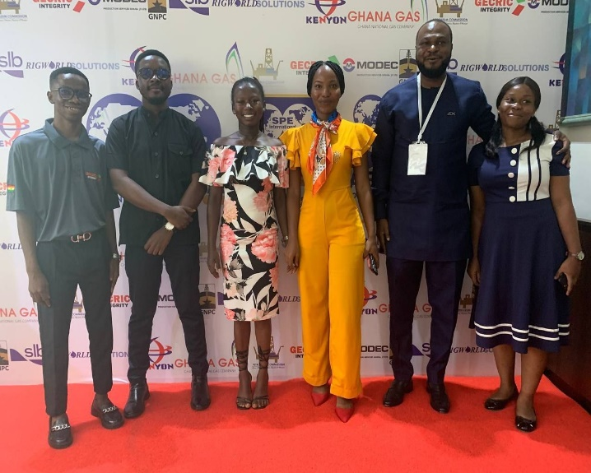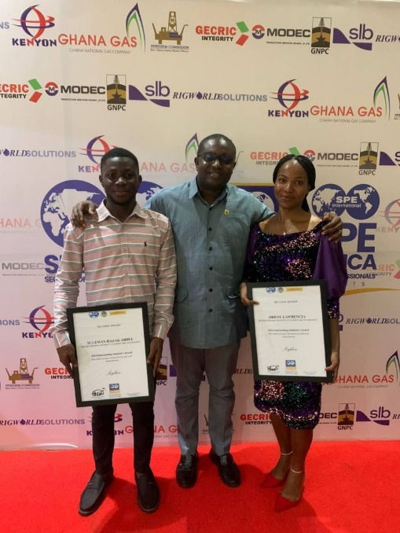
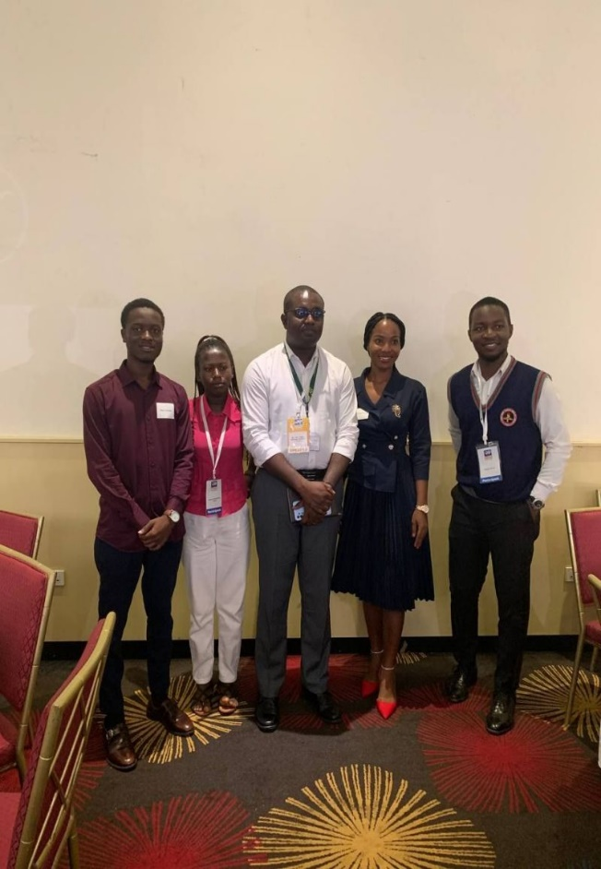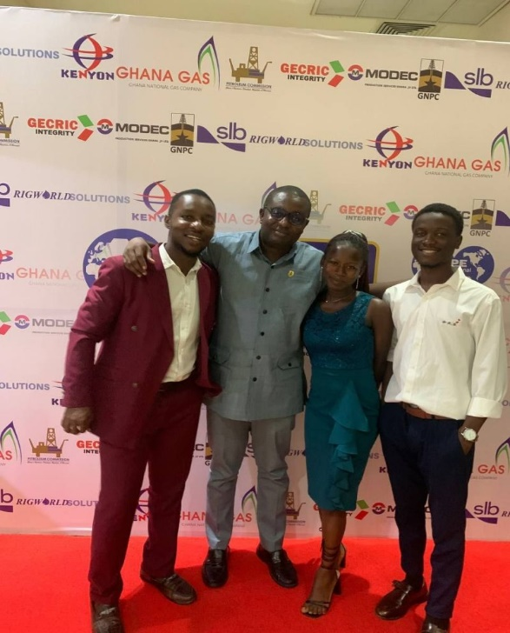

- INTER-COUNTRY COLLABORATION WITH SPE-LASU (Lagos University)
SPE KNUST was delighted to collaborate with SPE-LASU(Lagos State University) chapter on a monthly technical lecture on the topic, Net-zero Energy with Dr. Riverson Oppong( SPE Ghana Section director). This collaboration helped to foster a good network between the chapters setting the tone for future innovations.
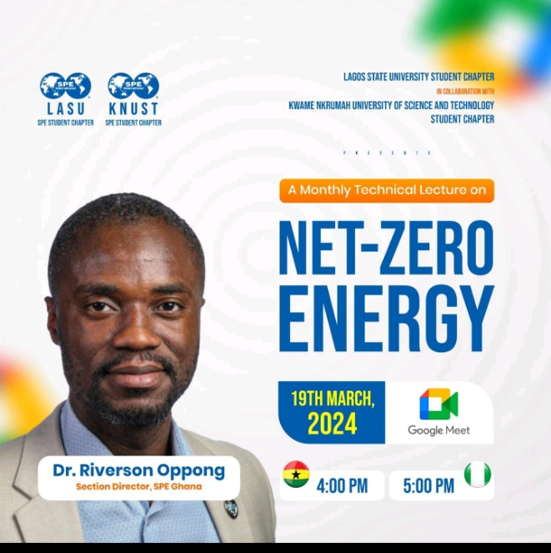

- SPE AFRICA DATATHON COMPETITION
Three of our members participated in the SPE datathon competition and we are proud to have one of our participants emerge as the first in position. Nhyiraba Appiah is a final year petroleum engineering student from KNUST who received his price in Lagos, Nigeria during the NAICE conference 2024.
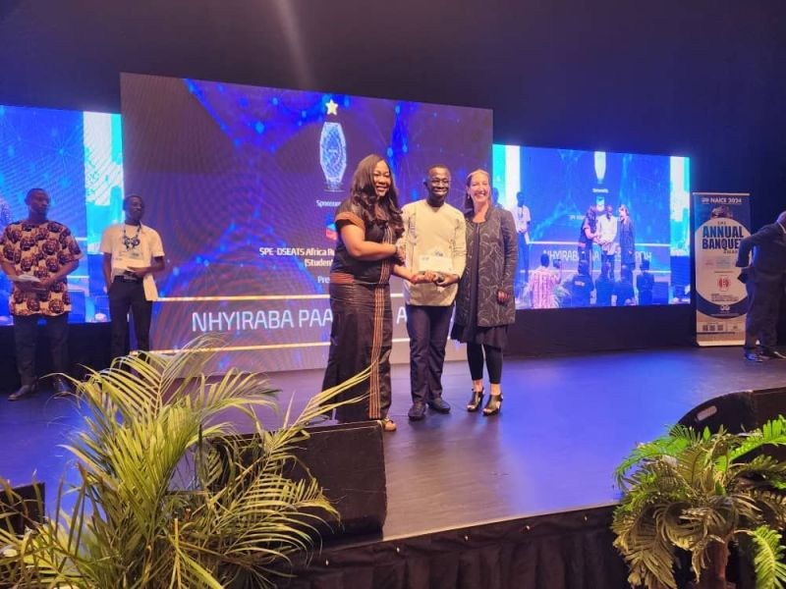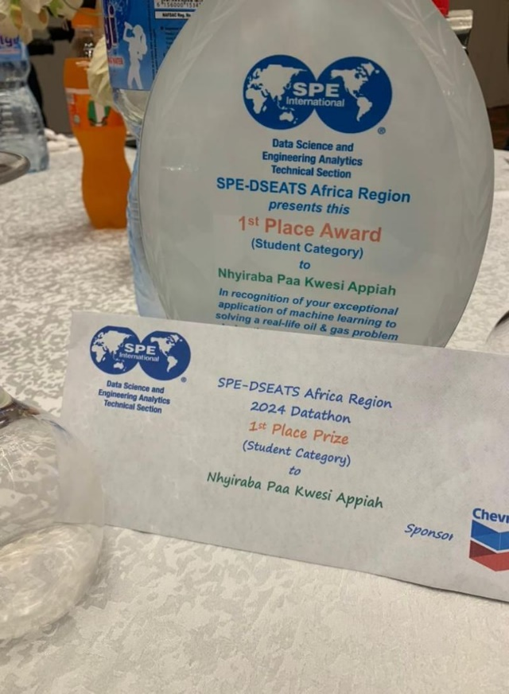

- FACULTY ADVISOR APPRECIATION
As we bring our tenure of service to a close, we took a moment to express our deepest gratitude to our patron Stephen Adjei, Ph.D. whose unwavering commitment and support has been the cornerstone of our society’s success over the year. His dedication, vision, and tireless efforts have not only guided us but have also inspired every member to strive for excellence.

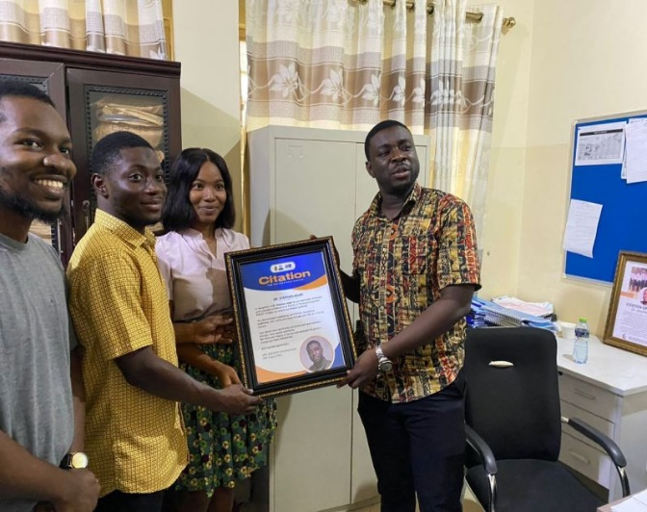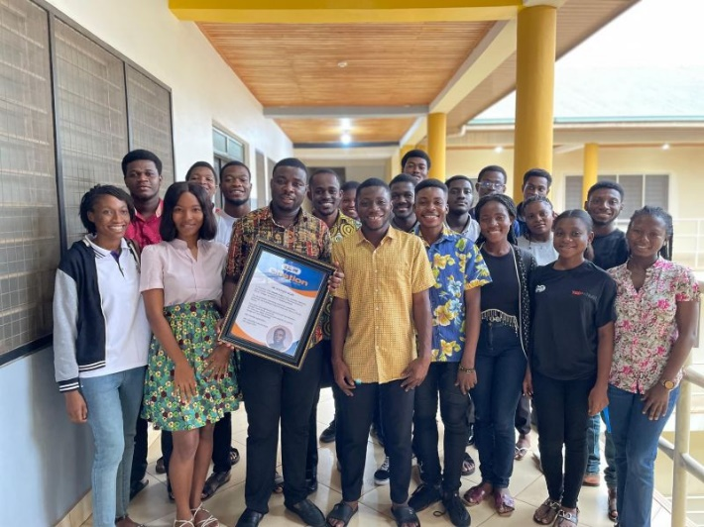

- HANDING OVER
After an incredible journey, we are excited to share that we are passing the baton to our newly appointed executives for the 2024/2025 academic year. It has been an honor to contribute to the Society of Petroleum Engineers - SPE Ghana Section as student volunteers working alongside such talented individuals. These individuals bring a wealth of experience and fresh perspective to the role, and we are confident they will continue to drive success and innovation. Please join us in welcoming them as they take on this new challenge.
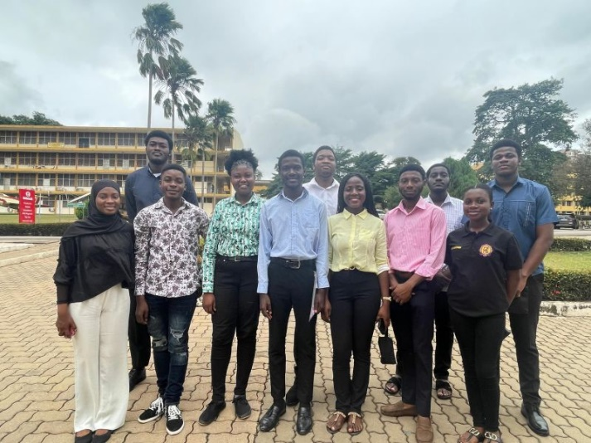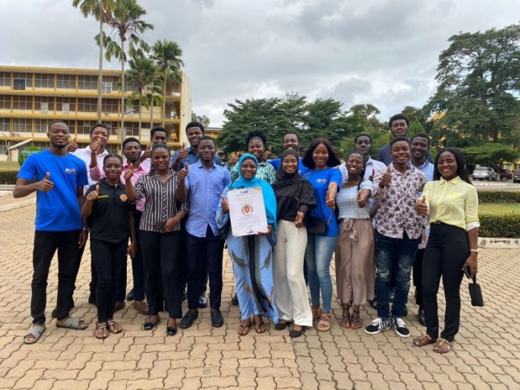
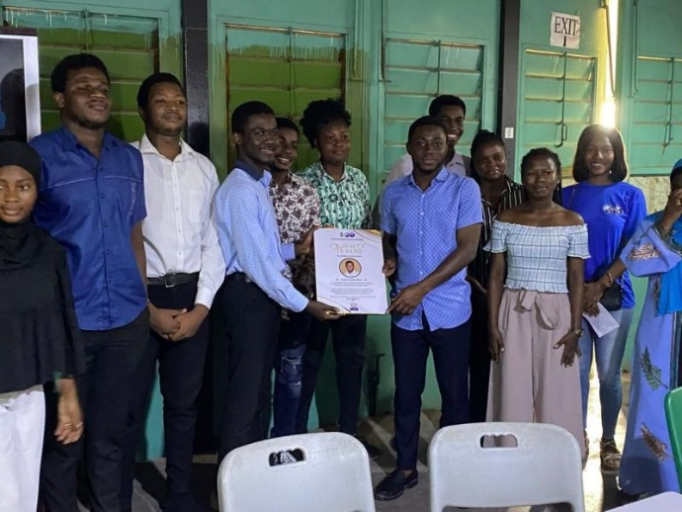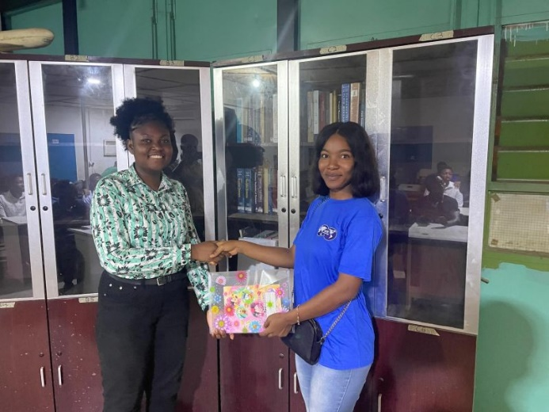

LIST FOR NEWLY APPOINTED EXECUTIVES
